**Ramrao Adik Institute of Technology**

**(Department of Computer Engineering)**



**Mini Project Report**

**On**

**STUDENT PROFILE MANAGMENT**

**Subject-: Object Oriented Programing Language**

***Presented By***

|  |  |  |
| --- | --- | --- |
| Roll No | Batch-Sr. No | Name |
|  |  |  |
| **18CE2011** | ***A3 / 4*** | ***DUBEY SUSHIL ANILKUMAR*** |
|  |  |  |
|  |  |  |

**TITLE :**t

**STUDENT PROFILE MANAGMENT**

|  |  |  |
| --- | --- | --- |
| Serial No. | Content | Page No. |
| 1. | AIM | 4 |
| 2. | INTRODUCTION | 4 |
| 3. | PACKAGES | 5 |
| 4. | PROGRAM DETAILS | 7 |
| 5. | SOURCE CODE | 14 |
| 6. | OUTPUT | 28 |

CONTENT

**AIM**

Develop a java based application using GUI to maintain student record. The application should have a login page. The application should take student details like name, address, branch, previous year scores, curricular and extra-curricular activities and all the entered data should be displayed in the end for conformation.

**INTRODUCTION**

A **GUI** (graphical user interface) is a system of interactive components such as icons and other graphical objects that help a user interact with computer software, such as an operating system.

A GUI is considered to be more user-friendly than a text-based command-line-interface , such as MS-DOS, or the shell of Unix-like operating systems.

The GUI was first developed at Xerox-PARC by Alan Kay, DogulasEngleBart , and a group of other researchers in 1981. Later, Apple introduced the Lisa computer with a GUI on January 19, 1983.

A GUI uses windows, icons, and menu to carry out commands, such as opening, deleting, and moving files. Although a GUI operating system is primarily navigated using a mouse, a keyboard can also be used via keyboard shortcuts or the arrow keys.

**Packages**

***javax.swing***

**Java Swing tutorial** is a part of Java Foundation Classes (JFC) that is used to create window-based applications. It is built on the top of AWT (Abstract Windowing Toolkit) API and entirely written in java.Unlike AWT, Java Swing provides platform-independent and lightweight components.

The javax.swing package provides classes for java swing API such as JButton, JTextField, JTextArea, JRadioButton, JCheckbox, JMenu, JColorChooser etc.

***java.awt***

The java.awt package is the main package of the AWT, or Abstract Windowing Toolkit. It contains classes for graphics, including the Java 2D graphics capabilities introduced in the Java 2 platform, and also defines the basic graphical user interface (GUI) framework for Java. The most important graphics classes in java.awt are Graphics and its Java 2D extension, Graphics2D. These classes represent a drawing surface, maintain a set of drawing attributes, and define methods for drawing and filling lines, shapes, and text. Classes that represent graphgics attributes include Color, Font, Paint, Stroke, and Composite.

***java.awt.event***

The **java**.**awt**.**event package** defines classes and interfaces used for **event** handling in the **AWT** and Swing. The members of this **package** fall into three categories: **Events**. The classes with names ending in "**Event**" represent specific types of **events**, generated by the **AWT** or by one of the **AWT** or Swing components.

***java.io.file***

**Java**.**io package** provides classes for system input and output through **files**, network streams, memory buffers, etc. Some **input-output** stream will be initialized automatically by the JVM and these streams are available in System class as in, out, and err variable.

***javax.swing.filechooser.FileNameExtensionFilter***

An implementation of FileFilter that filters using a specified set of extensions. The extension for a file is the portion of the file name after the last ".". Files whose name does not contain a "." have no file name extension.

***java.util.Scanner***

**Scanner** Class in **Java**. **Scanner** is a class in **java**.**util package** used for obtaining the input of the primitive types like int, double, etc. and strings. ... next() function returns the next token/word in the input as a string and charAt(0) function returns the first character in that string.

**Program Details –**

1. **LoginFrame** :

Login Frame is GUI based window that is displayed when the user first executes the program. It is the welcome page through which user will move on to the next frame.

It contains a button with an ActionListener() which on pressing opens Frame2.

1. **Frame2** :

Frame2 is login page. This page takes user id and password as input and only after successful verification of user the user is allowed to move to next page.

The default user id password is

User id :- admin

Password :- admin1234

1. **Frame3** :

Frame3 is where the user is given the option to enter their details such as name, age, branch, address and select their gender from the drop-down menu. Each detail to be entered are stored using JTextField() and JRadioButton is used to display the drop-down menu for the gender selection. Finally, there is the submit details button which on pressing triggers ActionListener() and checks whether the user given input is legitimate or not, if it is not then it pops a alert message that reminds the user to enter the correct details. Once the correct input is given, we pass this information onto Frame4.

1. **Frame4** :

Frame4 is where the user is given the option to enter their details such as their previous academics achievements, their 10th,12th scores, their average pointer, their extra-curricular and co-curricular activites. Each detail to be entered are stored using JTextField() and JRadioButton is used to display the drop-down menu for the gender selection. Finally, there is the submit details button which on pressing triggers ActionListener() and checks whether the user given input is legitimate or not, if it is not then it pops a alert message that reminds the user to enter the correct details. Once the correct input is given, we pass this information onto Frame5.

1. **Frame5 :**

Frame5 class is where we receive the user input taken in Frame3 and Frame4 and using JLabel()’s we display it on our Java application windows. There are two buttons to either make a new entry or to exit. On clicking on the first button, ActionListener() is triggered which calls Frame3() and thus we can enter details of the another entry.

1. **Student Detials :**

This is the final class that contains the main method, which calls the LoginFrame() .

**AWT/Swing Functions Used –**

1. **ActionListener :**

ActionListener in Java is a class that is responsible in handling all action events such as when user clicks in component, like JButton, the moment user clicks on it, the ActionListener immediately enforces the action which was programmed by the programmer.

E.g.

b1.addActionListener( new ActionListener()

{

Public void actionPerformed(ActionEvent e)

{

LoginFrame.this.setVisible(false);

new Frame2();

}

});

In this example we can see that an ActionListener is added to the JButton b1, then an action is programmed to take place using the actionPerformed() function. “new Frame2()” is action set by the user that creates a new Frame

1. **JFrame :**

The JFrame class is a type of container which inherits the java.awt.Frame class. JFrame works like the main window where components like labels, buttons, textfields are added to create a GUI. It is a container in which you put all the elements of your window in a GUI application.

Unlike Frame, JFrame has the option to hide or close the window with the help of setDefaultCloseOperation(int) method

**3) JButton :**

The JButton class is used to create a labeled button that has platform independent implementation. The application result in some action when the button is pushed. It inherits AbstractButton class.

Constructors of the class are:-

**JButton()** – To create a button with no text and icon.

**JButton(String s)** – To create a button with the specified text.

**JButton(Icon i)** – To create a button with a specified icon object.

1. **JLabel :**

JLabel is a class of java Swing . JLabel is used to display a short string or an image icon. JLabel can display text, image or both . JLabel is only a display of text or image and it cannot get focus . JLabel is inactive to input events such a mouse focus or keyboard focus. By default labels are vertically centered but the user can change the alignment of label.

Constructor of the class are :

**JLabel()** - creates a blank label with no text or image in it.

**JLabel(String s)** - creates a new label with the string specified.

**JLabel(Icon i)** - creates a new label with a image on it.

JLabel(String s, Icon i, int align) - creates a new label with a string, an image and a specified horizontal alignment

1. **JTextField –**

JTextField is a part of javax.swing package. The class JTextField is a component that allows editing of a single line of text. JTextField inherits the JTextComponent class and uses the interface SwingConstants.

The constructor of the class are :

**JTextField()** : constructor that creates a new TextField

**JTextField(int columns)** : constructor that creates a new empty TextField with specified number of columns.

**JTextField(String text)** : constructor that creates a new empty text field initialized with the given string.

**JTextField(String text, int columns)** : constructor that creates a new empty textField with the given string and a specified number of columns .

**JTextField(Document doc, String text, int columns)**: constructor that creates a textfield that uses the given text storage model and the given number of columns.

**SOURCE CODE**

import javax.swing.*;

import java.awt.event.*;

import java.awt.*;

import java.io.File;

import javax.swing.filechooser.FileNameExtensionFilter;

import java.util.*;

class LoginFrame extends JFrame

{

JButton b1 , b2;

JLabel l1;

public LoginFrame()

{

super("LOGIN PAGE");

setSize(800 , 550);

setResizable(true);

setLocation(200 , 50);

setLayout(null);

setDefaultCloseOperation(EXIT_ON_CLOSE);

b1 = new JButton(" START YOUR REGISTRATION FORM ");

b1.setBounds(250, 400 , 300 , 50);

add(b1);

l1 = new JLabel();

l1.setBounds(200, 30 , 700 , 300);

l1.setIcon(new ImageIcon("9.jpg"));

add(l1);

b1.addActionListener( new ActionListener()

{

public void actionPerformed(ActionEvent e)

{

LoginFrame.this.setVisible(false);

new Frame2();

}

});

setVisible(true);

}

}

class Frame2 extends JFrame

{

JLabel l1,l2;

JTextField t1,t2;

JButton b1;

public Frame2()

{

super("LOGIN PAGE");

setSize(500 , 500);

setResizable(true);

setLocation(200 , 50);

setLayout(null);

setDefaultCloseOperation(EXIT_ON_CLOSE);

l1 = new JLabel("USERNAME: ");

l1.setBounds(80,150,150,30);

add(l1);

t1 = new JTextField();

t1.setBounds(230,150,200,30);

add(t1);

l2 = new JLabel(" PASSWORD: ");

l2.setBounds(80 , 190 , 150 , 30);

add(l2);

t2 = new JTextField();

t2.setBounds(230 , 190 , 200 , 30);

add(t2);

b1 = new JButton("LOGIN");

b1.setBounds(150 , 330 , 150, 30);

add(b1);

b1.addActionListener(new ActionListener()

{

public void actionPerformed(ActionEvent ae)

{

if(t1.getText().equals(""))

{

JOptionPane.showMessageDialog(Frame2.this,"Please Enter USERNAME","ALERT",JOptionPane.ERROR_MESSAGE);

return;

}

else if(t2.getText().equals(""))

{

JOptionPane.showMessageDialog(Frame2.this,"Please Enter PASSWORD","ALERT",JOptionPane.ERROR_MESSAGE);

return;

}

else if(t1.getText().equals("admin") && t2.getText().equals("admin1234"))

{

Frame2.this.setVisible(false);

new Frame3();

}

else

{

JOptionPane.showMessageDialog(Frame2.this,"USERID OR WORNG IS WORNG","ALERT",JOptionPane.ERROR_MESSAGE);

return;

}

}

});

setVisible(true);

}

}

class Frame3 extends JFrame

{

JLabel l1,l2,l3,l4,l5,l6,l7;

JTextField t1,t2,t3,t4,t5;

JButton b1, b2, b3;

String data;

public Frame3()

{

super("STUDENT DETAILS");

setSize(500 , 500);

setResizable(true);

setLocation(200 , 50);

setLayout(null);

setDefaultCloseOperation(EXIT_ON_CLOSE);

l1 = new JLabel("ENTER FIRST NAME ");

l1.setBounds(80 , 50 , 150 , 30);

add(l1);

t1 = new JTextField();

t1.setBounds(230 , 50 , 200 , 30);

add(t1);

l2 = new JLabel("ENTER LAST NAME ");

l2.setBounds(80 , 100 , 150 , 30);

add(l2);

t2 = new JTextField();

t2.setBounds(230 , 100 , 200 , 30);

add(t2);

l3 = new JLabel("SELECT GENDER ");

l3.setBounds(80,150,150,30);

add(l3);

t5 = new JTextField();

t5.setBounds(230,150,200,30);

add(t5);

l4 = new JLabel(" ENTER BRANCH ");

l4.setBounds(80 , 190 , 150 , 30);

add(l4);

t3 = new JTextField();

t3.setBounds(230 , 190 , 200 , 30);

add(t3);

l5 = new JLabel("ENTER ADDRESS ");

l5.setBounds(80 , 230 , 150 , 30);

add(l5);

t4 = new JTextField();

t4.setBounds(230 , 230 , 200 , 30);

add(t4);

b2 = new JButton("SUBMIT DETAILS");

b2.setBounds(150 , 330 , 150, 30);

add(b2);

b2.addActionListener(new ActionListener()

{

public void actionPerformed(ActionEvent ae)

{

if(t1.getText().equals(""))

{

JOptionPane.showMessageDialog(Frame3.this,"Please Enter FIRST NAME","ALERT",JOptionPane.PLAIN_MESSAGE);

return;

}

else if(t2.getText().equals(""))

{

JOptionPane.showMessageDialog(Frame3.this,"Please Enter LAST NAME","ALERT",JOptionPane.PLAIN_MESSAGE);

}

else if(t5.getText().equals(""))

{

JOptionPane.showMessageDialog(Frame3.this,"Please Enter GENDER","ALERT",JOptionPane.PLAIN_MESSAGE);

}

else if(t3.getText().equals(""))

{

JOptionPane.showMessageDialog(Frame3.this,"Please Enter DEPARTMENT","ALERT",JOptionPane.PLAIN_MESSAGE);

}

else if(t4.getText().equals(""))

{

JOptionPane.showMessageDialog(Frame3.this,"Please Enter ADDRESS","ALERT",JOptionPane.PLAIN_MESSAGE);

}

else

{

String s1 = "STUDENT NAME : "+t1.getText().trim()+" "+t2.getText().trim()+"\n";

String s2 = "ADDRESS : "+t4.getText().trim();

String s3 = "BRANCH : "+t3.getText().trim();

String s4 = "GENDER : "+t5.getText().trim();

Frame3.this.setVisible(false);

new Frame4(s1,s2,s3,s4);

}

}

});

setVisible(true);

}

}

class Frame4 extends JFrame

{

JLabel l1,l2,l3,l4,l5,l6,l7;

JTextField t1,t2,t3,t4,t5;

JButton b1, b2, b3;

String data;

public Frame4(String s1, String s2, String s3, String s4)

{

super("STUDENT DETAILS");

setSize(500 , 500);

setResizable(true);

setLocation(200 , 50);

setLayout(null);

final String s5= s1;

final String s6= s2;

final String s7= s3;

final String s8= s4;

setDefaultCloseOperation(EXIT_ON_CLOSE);

l1 = new JLabel("ENTER SSC PERCENTAGE: ");

l1.setBounds(40 , 50 , 150 , 30);

add(l1);

t1 = new JTextField();

t1.setBounds(270 , 50 , 200 , 30);

add(t1);

l2 = new JLabel("ENTER HSC PERCENTGE: ");

l2.setBounds(40 , 100 , 150 , 30);

add(l2);

t2 = new JTextField();

t2.setBounds(270 , 100 , 200 , 30);

add(t2);

l3 = new JLabel("ENTER YOUR AVERAGE POINTER: ");

l3.setBounds(40,150,200,30);

add(l3);

t5 = new JTextField();

t5.setBounds(270,150,200,30);

add(t5);

l4 = new JLabel(" HAVE ENROLED FOR NTPEL: ");

l4.setBounds(40 , 190 , 200 , 30);

add(l4);

t3 = new JTextField();

t3.setBounds(270 , 190 , 200 , 30);

add(t3);

l5 = new JLabel("HAVE YOU JIONED ANY COMMITIE: ");

l5.setBounds(40 , 230 , 200 , 30);

add(l5);

t4 = new JTextField();

t4.setBounds(270 , 230 , 200 , 30);

add(t4);

b2 = new JButton("CONTINUE");

b2.setBounds(150 , 330 , 150, 30);

add(b2);

b2.addActionListener(new ActionListener()

{

public void actionPerformed(ActionEvent ae)

{

if(t1.getText().equals(""))

{

JOptionPane.showMessageDialog(Frame4.this,"Please Enter SSC PERCENTAGE","ALERT",JOptionPane.PLAIN_MESSAGE);

return;

}

else if(t2.getText().equals(""))

{

JOptionPane.showMessageDialog(Frame4.this,"Please Enter HSC MARKS","ALERT",JOptionPane.PLAIN_MESSAGE);

}

else if(t5.getText().equals(""))

{

JOptionPane.showMessageDialog(Frame4.this,"Please Enter AVERAGE POINTER","ALERT",JOptionPane.PLAIN_MESSAGE);

}

else if(t3.getText().equals(""))

{

JOptionPane.showMessageDialog(Frame4.this,"Please Enter COMMITTE NAME","ALERT",JOptionPane.PLAIN_MESSAGE);

}

else if(t4.getText().equals(""))

{

JOptionPane.showMessageDialog(Frame4.this,"Please Enter NTEPL COURSE","ALERT",JOptionPane.PLAIN_MESSAGE);

}

else

{

String s9 = "SSC PERCENTAGE "+t1.getText().trim();

String s10 = "HSC PERCENTAGE "+t2.getText().trim()+"\n";

String s11 = " COMMITTE: "+t4.getText().trim();

String s12 = "NTEPL COURSE NAME : "+t3.getText().trim();

String s13 = "AVERAGE POINTER : "+t5.getText().trim();

Frame4.this.setVisible(false);

new Frame5(s5,s6,s7,s8,s9,s10,s11,s12,s13);

}

}

});

setVisible(true);

}

}

class Frame5 extends JFrame

{

JLabel l1 , l2, l3, l4, l5,l6,l7,l8,l9,l10;

JButton b1, b2;

public Frame5(String s1, String s3, String s2, String s4, String s5, String s6, String s7, String s8,String s9 )

{

super("STUDENT");

setSize(1000 , 900);

setResizable(true);

setLocation(200 , 70);

setLayout(null);

setDefaultCloseOperation(EXIT_ON_CLOSE);

l1 = new JLabel(s1);

l1.setBounds(50 , 20 , 300 , 30);

add(l1);

l4 = new JLabel(s4);

l4.setBounds(50 , 70 , 300 , 30);

add(l4);

l2 = new JLabel(s2);

l2.setBounds(50 , 120 , 300 , 30);

add(l2);

l3 = new JLabel(s3);

l3.setBounds(50 , 170 , 300 , 30);

add(l3);

l5 = new JLabel(s5);

l5.setBounds(50 , 220 , 300 , 30);

add(l5);

l6 = new JLabel(s6);

l6.setBounds(50 , 270 , 300 , 30);

add(l6);

l7 = new JLabel(s7);

l7.setBounds(50 , 320 , 300 , 30);

add(l7);

l8 = new JLabel(s8);

l8.setBounds(50 , 370 , 300 , 30);

add(l8);

l9 = new JLabel(s9);

l9.setBounds(50 , 420 , 300 , 30);

add(l9);

b1 = new JButton(" MAKE A NEW ENTERY ");

b1.setBounds(250, 400 , 150 , 50);

add(b1);

b2 = new JButton(" EXIT ");

b2.setBounds(400, 400 , 150 , 50);

add(b2);

b1.addActionListener( new ActionListener()

{

public void actionPerformed(ActionEvent e)

{

setVisible(false);

new Frame3();

}

});

b2.addActionListener( new ActionListener()

{

public void actionPerformed(ActionEvent e)

{

System.exit(0);

}

});

setVisible(true);

}

}

public class Studentdetails

{

public static void main(String [] args)

{

new LoginFrame();

}

}

**OUTPUT**

Welcome page

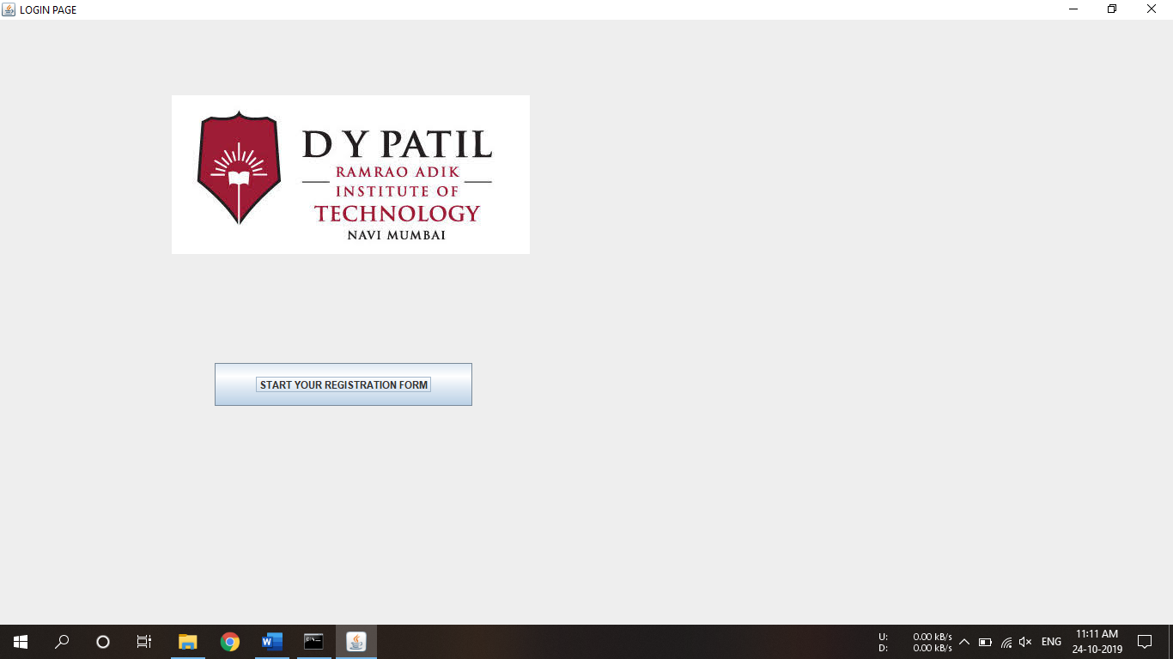

Login Frame

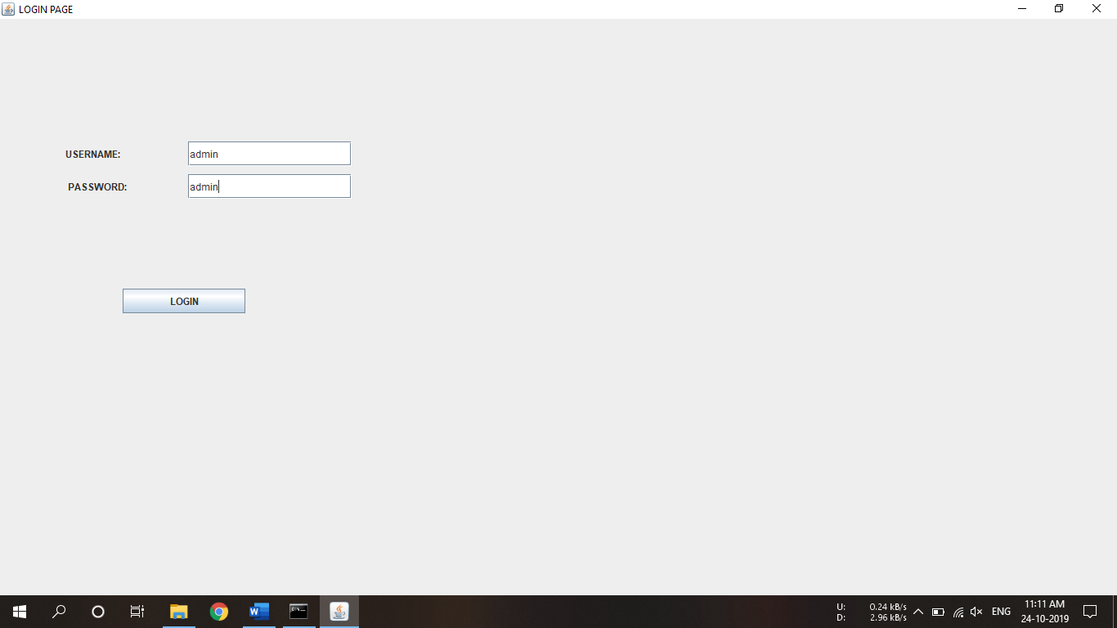

Credential verification

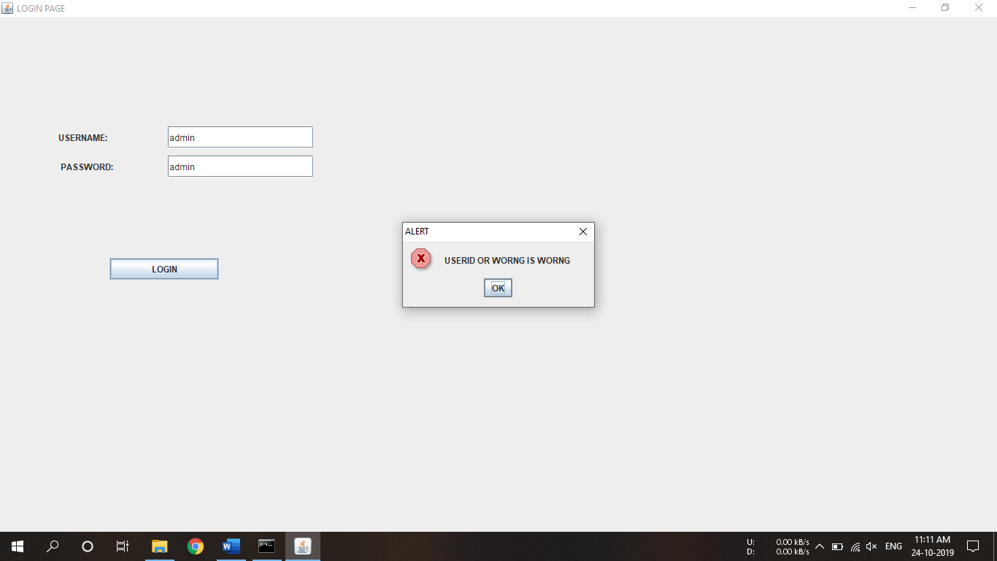

User input

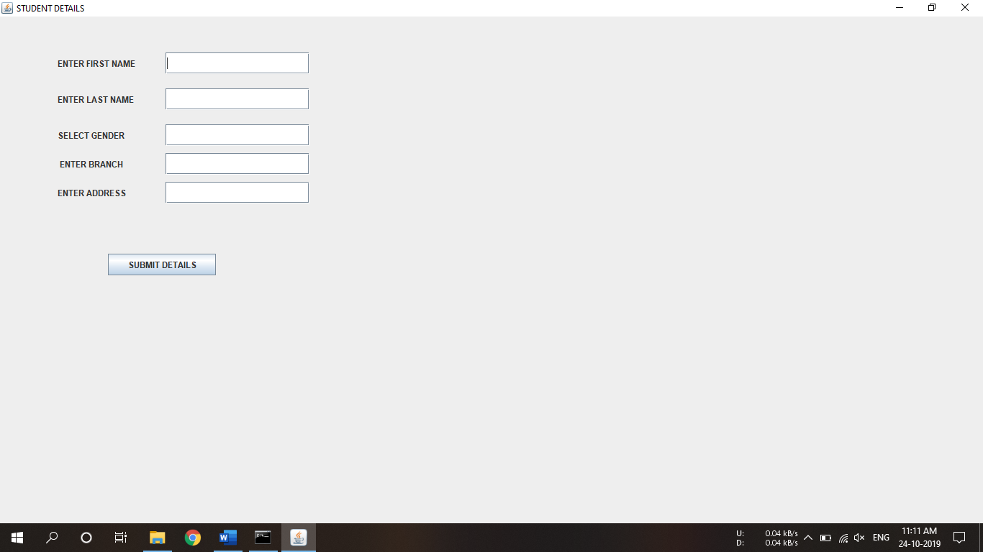

User input verification

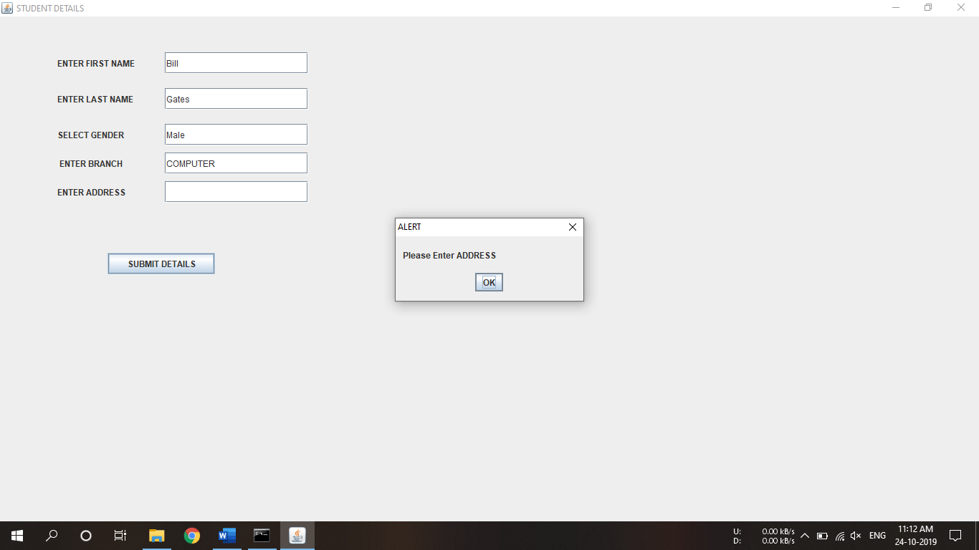

Additional inputs

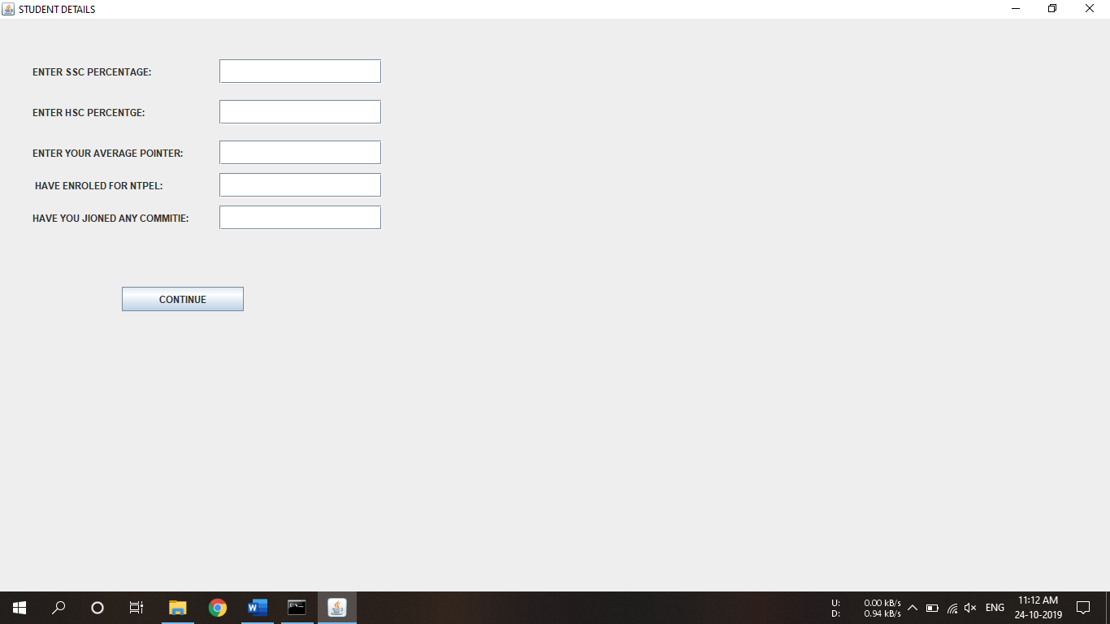

User input verfication

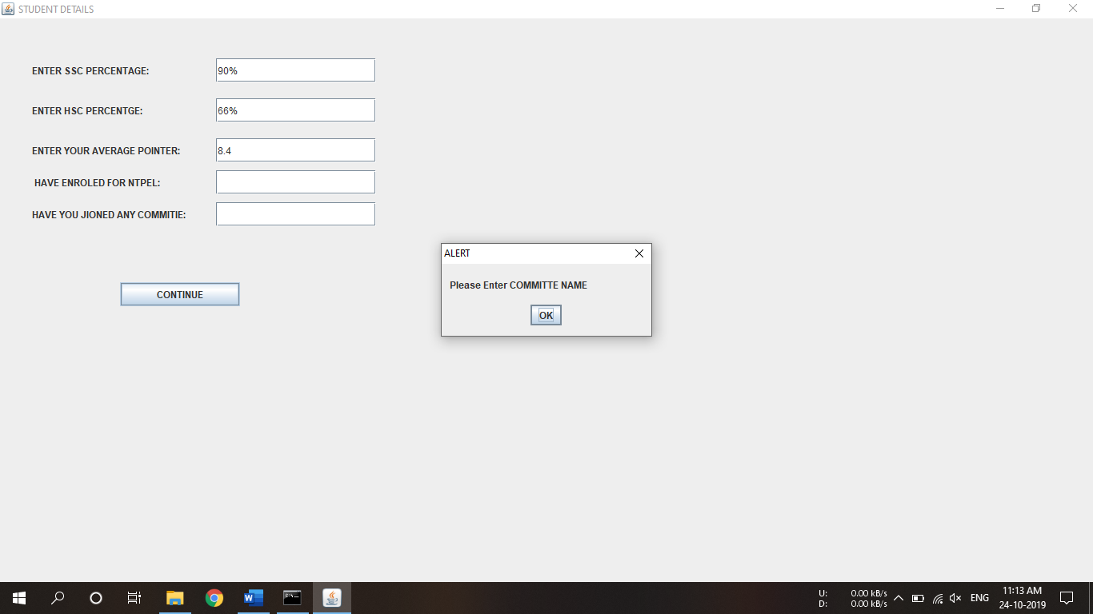

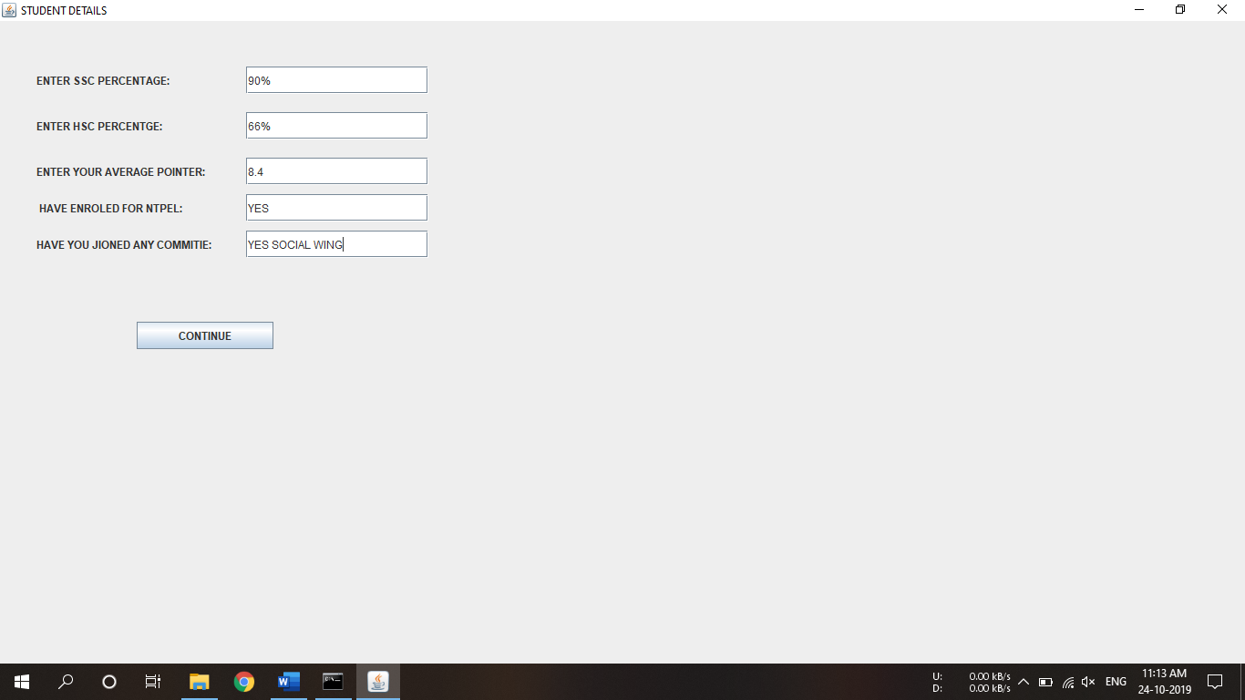

Displaying user details

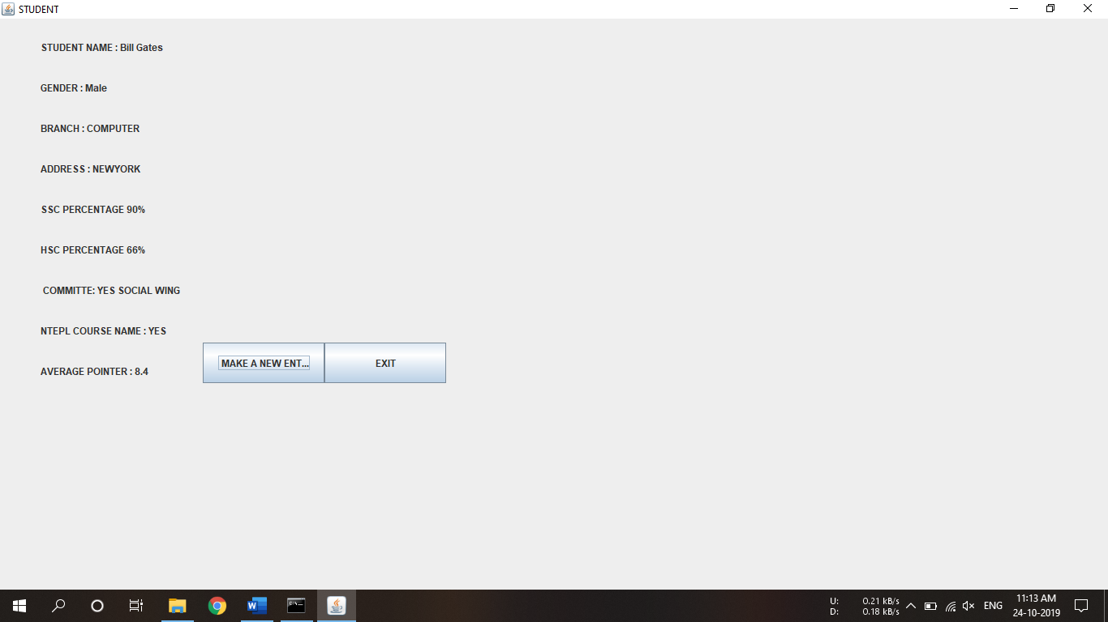

Making new entry

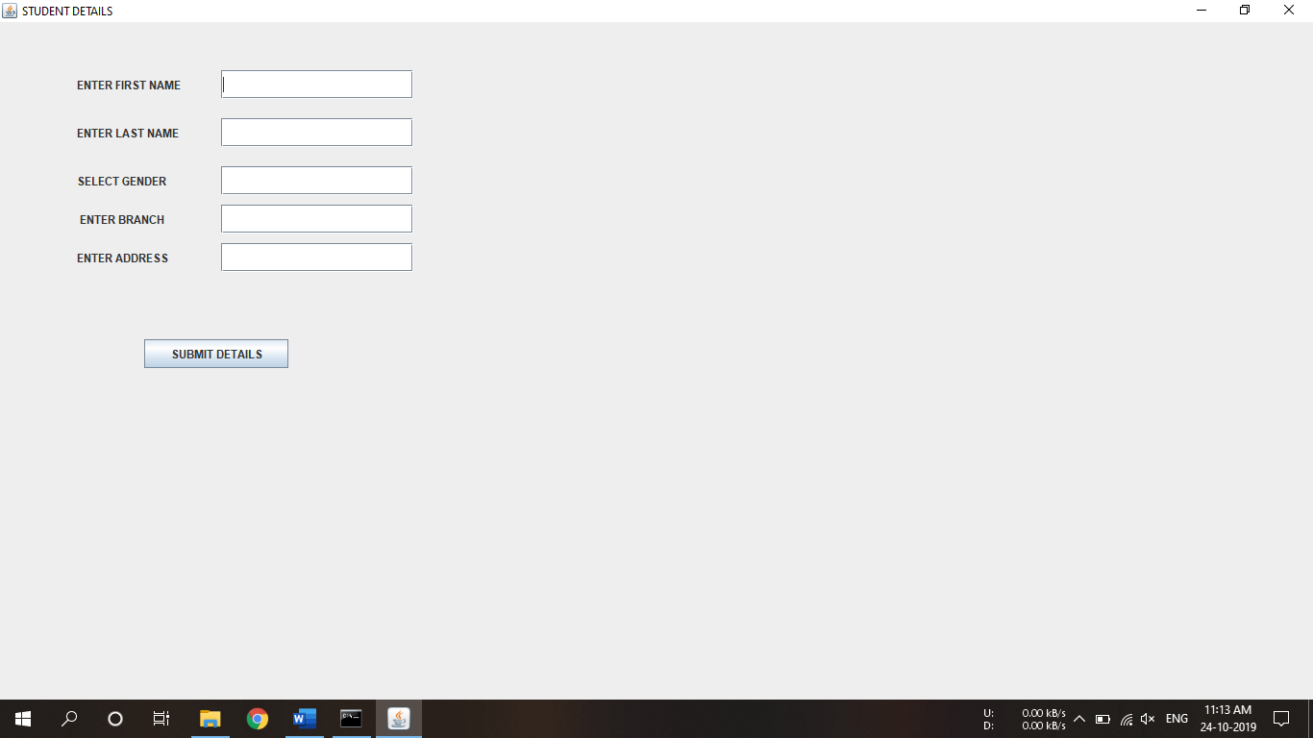

**CONCLUSION:**

Thus, using a GUI based java application we have successfully created a application with a welcome page , , login verification page ,which takes various student details as input, verifies them and displays it in the end.

A major advantage of GUI is that it makes computer operation more intuitive and thus easier to learn and use.

Icons are more user friendly than long command lines. GUIs provide the user with immediate,visual feedback about the effect of each action.